Deployed Database Evidence
This document shows that the Innovatech database has been deployed with Terraform and is working.

1. Database Server (Terraform)
The database runs on a t3.small EC2 instance in the data subnet (10.0.3.0/25), which has no route in from the internet. It uses the data tier security group, so only the web servers (MySQL, port 3306) and the monitoring server (metrics, port 9100) can connect to it. The disk is encrypted. IMDSv2 is require, which protects the server’s AWS credentials. The instance profile lets administrators manage it through Systems Manager and lets it read its own passwords.
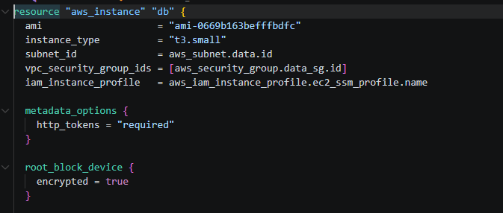
Figure 1: 5-database.tf: database instance definition

1.1 Automated MySQL Setup
The user_data script configures the server the first time it starts. It fetches the root and application passwords from SSM Parameter Store, installs MySQL 8 Community Server, and replaces MySQL’s temporary root password. It then creates the innovatech database and the visits table, and creates a separate appuser account that only has rights on the innovatech database. The website uses this account, never root. Finally, MySQL is set to listen on the network so the web servers can reach it. The security group still decides who is allowed to connect.
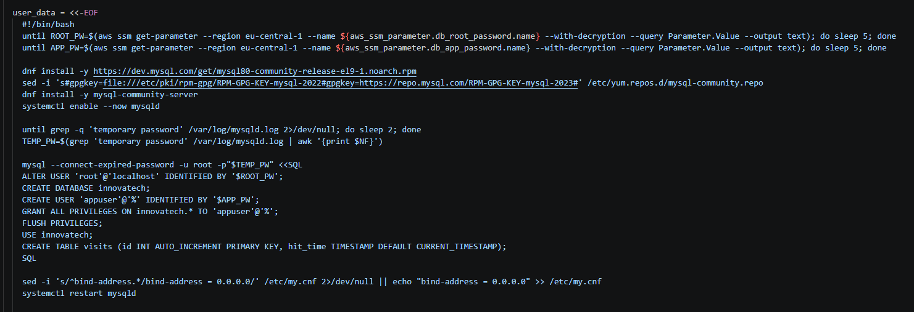
Figure 2: 5-database.tf: user_data script that installs and configures MySQL

2. Password Management

2.1 Generated Passwords in SSM Parameter Store
No passwords are written in the code. Terraform generates two random 24-character passwords, one for root and one for the application user. It stores them in SSM Parameter Store as SecureString parameters, which are encrypted with AWS KMS.
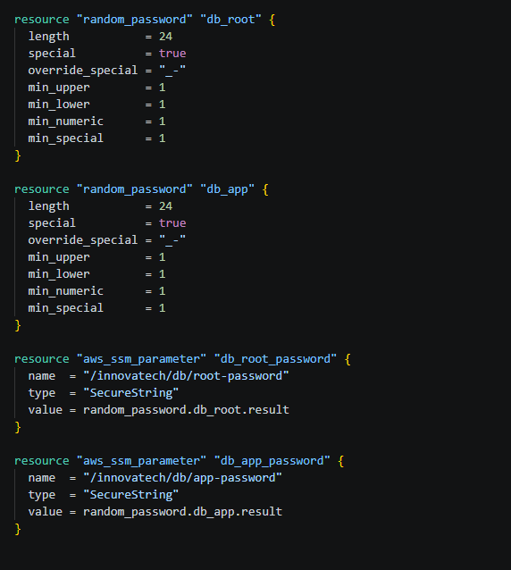
Figure 3: 3-secrets.tf: generated passwords stored as SecureString parameters

2.2 Least-Privilege Access to the Passwords
The EC2 role has two parts. AmazonSSMManagedInstanceCore lets administrators connect through Session Manager, with no SSH keys or open ports. A separate inline policy allows ssm:GetParameter on the two database password parameters only, so the servers cannot read any other secrets in the account.
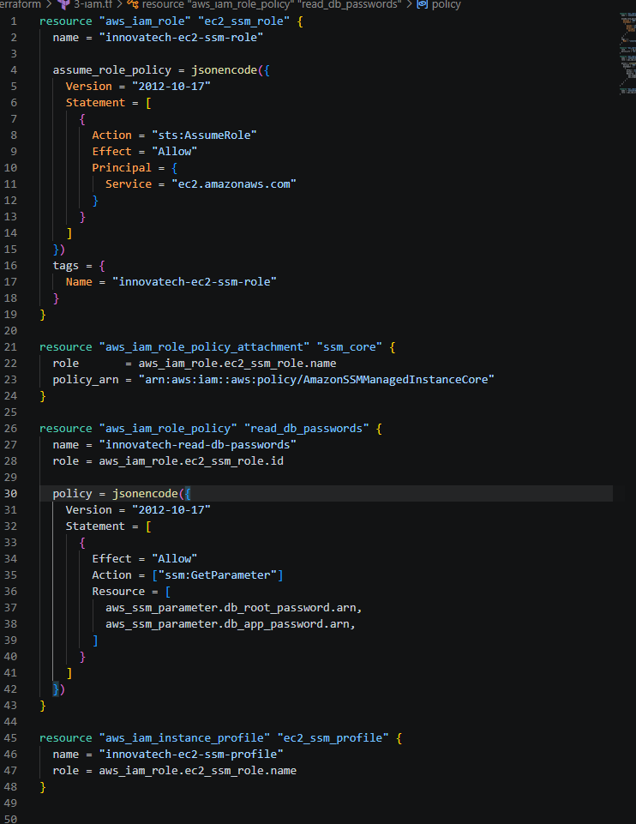
Figure 4: 3-iam.tf: EC2 role, Session Manager access and the password read policy

2.3 How the Web Servers Connect
When a web server starts, it fetches the application password from Parameter Store. It writes a db.ini file containing the database’s private IP address (filled in by Terraform), the appuser account and the database name. The file can only be read by root and the web server group (chmod 640). The PHP page reads its connection details from this file, so the password never appears in the application code.
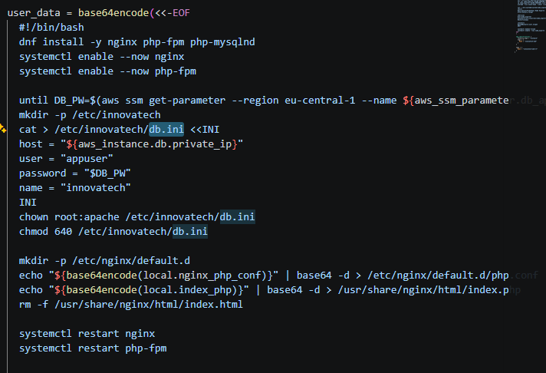
Figure 5: 4-web-launch-template.tf: web servers building their database connection file

3. Deployed Database (AWS Console)
The innovatech-db instance is Running. It has only a private IP address (10.0.3.83, inside the data subnet) and no public IP or public DNS name, so it cannot be reached from the internet.
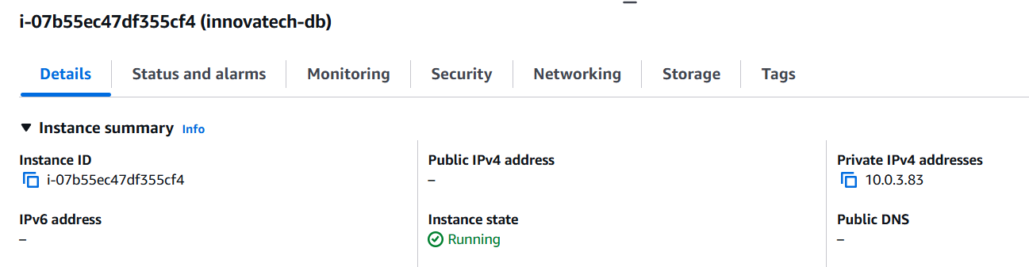
Figure 6: AWS console: innovatech-db running with a private IP only
The instance’s disk is attached and shows Encrypted: Yes with a KMS key, as set in the Terraform code.
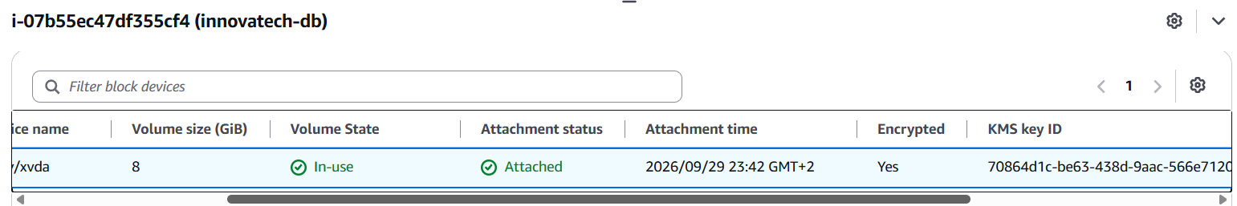
Figure 7: AWS console: encrypted root volume
Both password parameters exist in Parameter Store as SecureString. The values are hidden and are never shown in these screenshots.
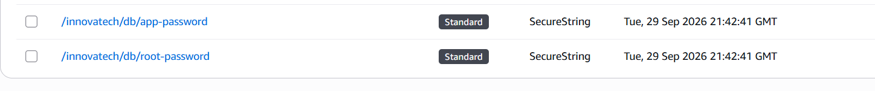
Figure 8: AWS console: database passwords stored as SecureString parameters

4. Database Is Working

4.1 Querying the Database
This output comes from a Session Manager session on the database server, with no SSH involved. The root password was loaded from Parameter Store into a shell variable, so it never appears on screen. The output confirms that the innovatech database exists and that the visits table contains data. It also shows that appuser is the only application account. The warning line is MySQL’s standard notice about passing a password on the command line.
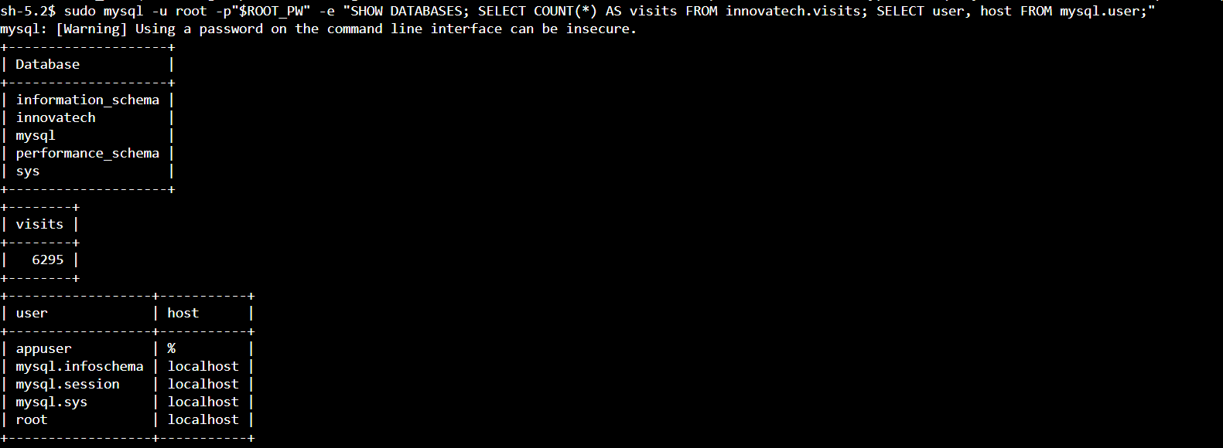
Figure 9: Session Manager: databases, visit count and user accounts on innovatech-db

4.2 Test Through the Website
The website was opened through the load balancer’s public address. The page was served by a web server in the private web subnet (10.0.2.165). It shows the number of visits recorded in the database, and this number goes up every time the page loads. This proves the whole path works: internet → load balancer → Transit Gateway → web server → database. The count here (6,292) is a little lower than in Figure 9 (6,295) because I took the screenshot of the website so more visitors were recorded in between.
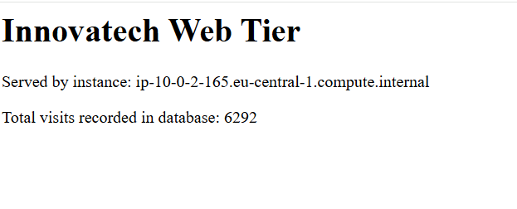
Figure 10: Innovatech web tier reading the visit count from the database

Summary
The database is defined entirely in Terraform. It is set up automatically when it starts and sits in a private subnet that only the web and monitoring tiers can reach. Its disk is encrypted, and its passwords are generated and stored in SSM Parameter Store, never in code. The console screenshots confirm it is deployed, and the query output and the live website show it storing and serving data.

